Ewalt Volschenk

Week 2: practical

Virtual Network
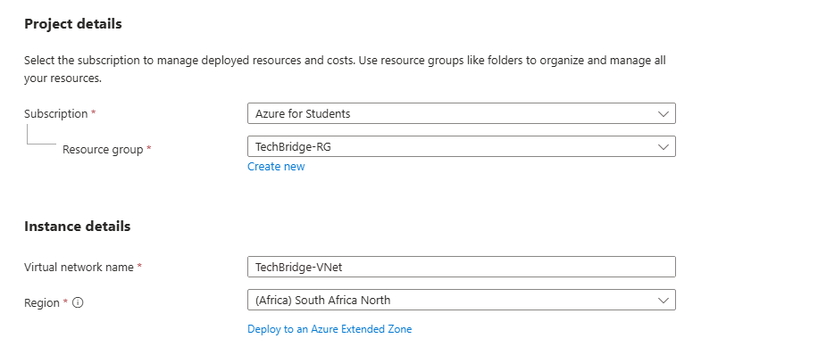
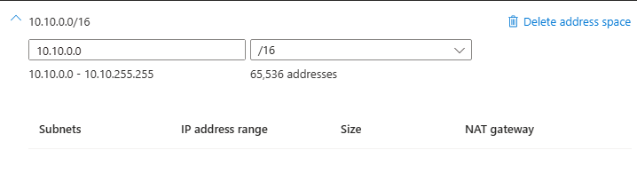
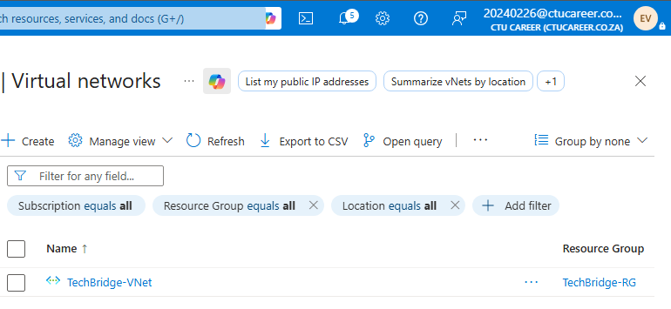
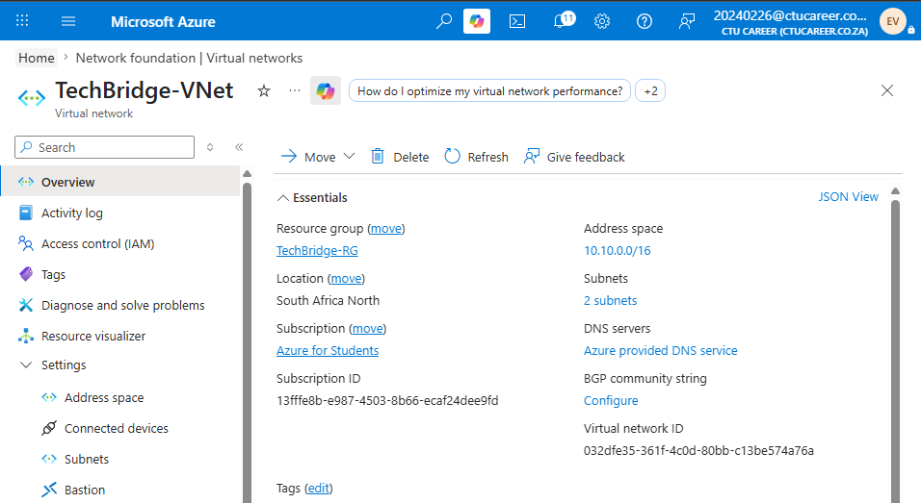

Subnets
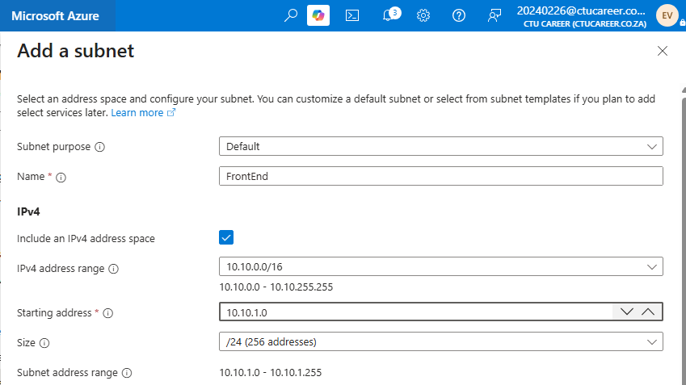
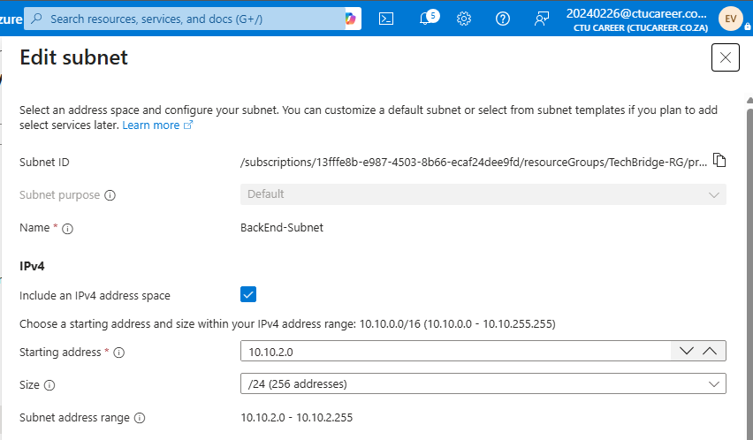
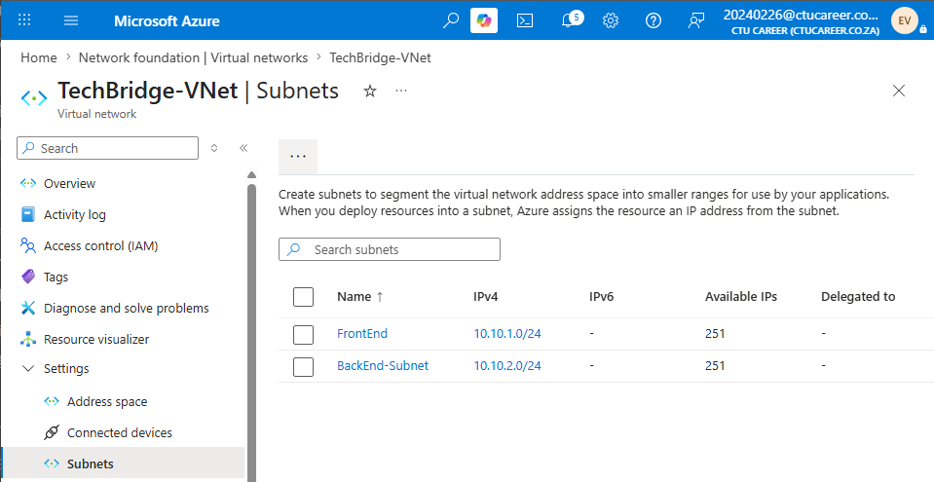

Network Security Group
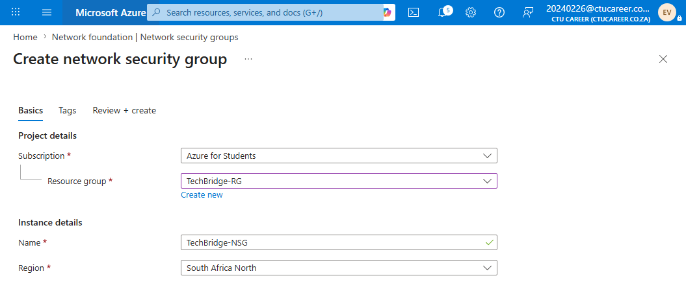
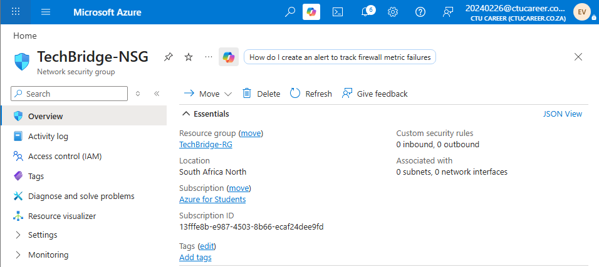
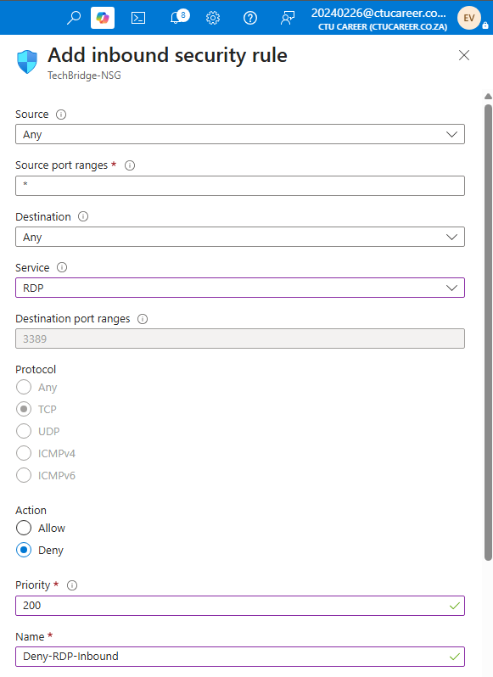
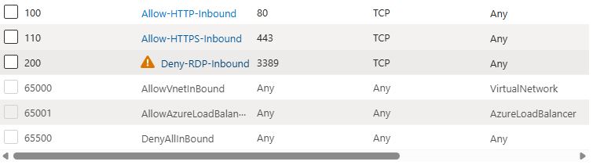
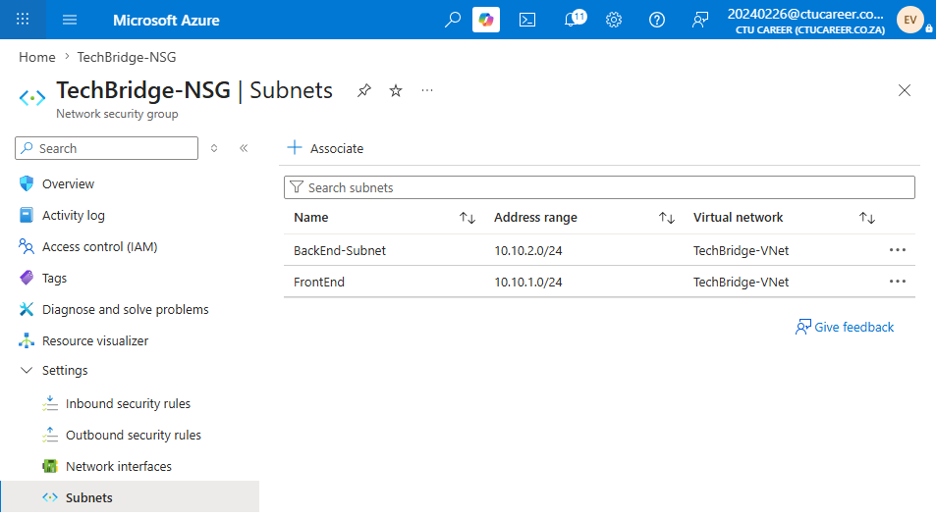

Task 4: README
Name: Ewalt Volschenk
Student Number: 20240226
Scenario Description: A Virtual Network must be designed which separates public and internal systems.s
Address space justification: I selected 10.10.0.0/16 was selected as it is a private range that is unlikely to conflict with existing office or home networks, and the /16 prefix provides space for future subnet expansion without requiring network redesign.
Subnet sizing justification: I used a /24 mask for both subnets which provides 254 usable host addresses each. This is appropriate for a small business and leaves the remaining space within the /16 available for additional subnets as the business grows.

Address Space summary
Resource | Name | CIDR | Address Range | Usable Hosts
Virtual Network | TechBridge-VNet | 10.10.0.0/16 | 10.10.0.0 – 10.10.255.255 | 65,534
Subnet 1 | FrontEnd-Subnet | 10.10.1.0/24 | 10.10.1.0 – 10.10.1.255 | 254
Subnet 2 | BackEnd-Subnet | 10.10.2.0/24 | 10.10.2.0 – 10.10.2.255 | 254

NSG Rules

Allow-HTTP-Inbound: Allows standard HTTP traffic from the internet to reach web servers hosted in the FrontEnd-Subnet
Allow-HTTPS-Inbound: Allows TLS-encrypted HTTPS traffic.
Deny-RDP-Inbound: Explicitly blocks Remote Desktop Protocol access from the internet.

Network Topology
